Homework9 Zhou, Tiancong

Question 1

<persons>   
{  
**for $p** **in** *doc*("persons.xml")/**personnel**/**person**,  
 **$n** **in $p**/**name**,  
 **$fn** **in $n**/**family**,  
 **$gn** **in $n**/**given**  
**let** **$space** := '&#32;'  
**where**   
 **$fn**="Boss"  
  
**return**  
<persons>  
 <found>{**$gn**/*text*() } {**$space**} {**$fn**/*text*()}</found>  
</persons>  
}  
</persons>

Result:

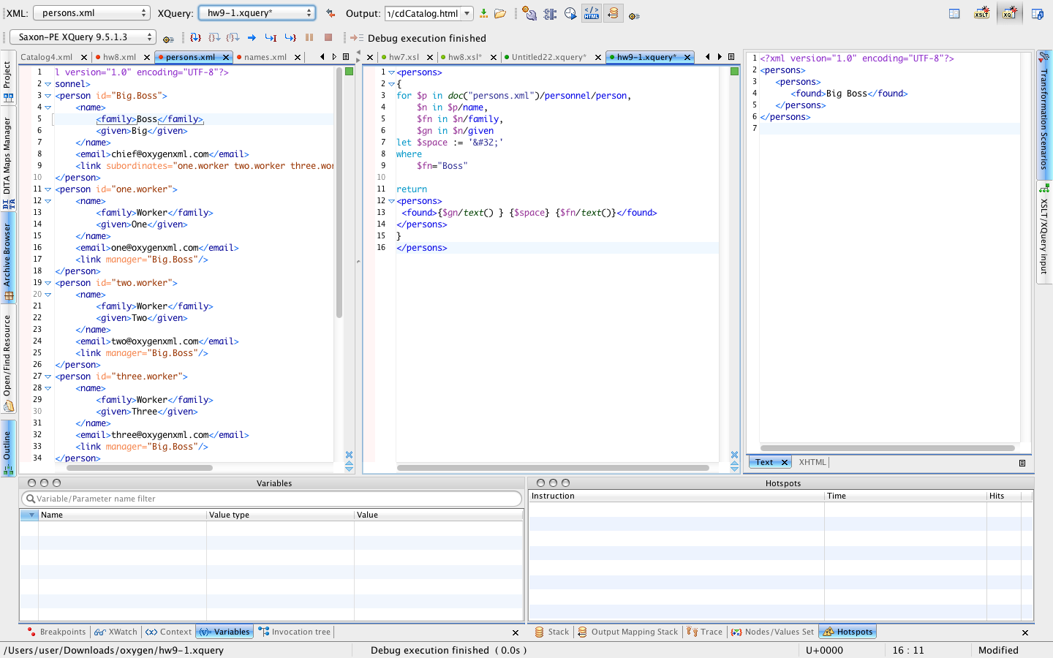

Question 2

<root>  
{  
**for $p** **in** *doc*("persons.xml")/**personnel**/**person**,  
 **$n** **in $p**/**name**,  
 **$fn** **in $n**/**family**,  
 **$gn** **in $n**/**given**,  
 **$l** **in $p**/**link**/***@\****,  
  
 **$n2** **in** *doc* ("names.xml")/**names**,  
 **$w** **in $n2**/**who**  
**let** **$space** := '&#32;'   
   
**where**   
 **$fn**=**$w**  
   
**return**   
 <person>  
 <name>  
 {**$p**/**name**/**given**/*text*()} {**$space**} {**$p**/**name**/**family**/*text*()}  
 </name>  
 <email>  
 {**$p**/**email**/*text*()}  
 </email>  
 <boss>  
 {**$l**/*string*()}  
 </boss>  
 </person>   
}  
</root>

Result:

